**Exercise 1: Ranking and Window Functions**

Goal: Use ROW_NUMBER(), RANK(), DENSE_RANK(), OVER(), and PARTITION BY.

Scenario:

Find the top 3 most expensive products in each category using different ranking functions.

Steps:

1. Use ROW_NUMBER() to assign a unique rank within each category.

2. Use RANK() and DENSE_RANK() to compare how ties are handled.

3. Use PARTITION BY Category and ORDER BY Price DESC

**CODE:**

CREATE TABLE Products (

ProductID INT PRIMARY KEY,

ProductName VARCHAR(100),

Category VARCHAR(50),

Price DECIMAL(10, 2)

);

INSERT INTO Products VALUES

(1, 'Ultra HD TV', 'Electronics', 1999.99),

(2, 'Wireless Headphones', 'Electronics', 349.99),

(3, 'Smartphone Pro', 'Electronics', 1099.99),

(4, 'Bluetooth Speaker', 'Electronics', 129.99),

(5, 'Laptop Elite', 'Electronics', 2499.99),

(6, 'Leather Sofa', 'Furniture', 1799.99),

(7, 'Dining Table', 'Furniture', 899.99),

(8, 'Office Chair', 'Furniture', 299.99),

(9, 'Coffee Table', 'Furniture', 199.99),

(10, 'King Size Bed', 'Furniture', 1299.99),

(11, 'Running Shoes', 'Sports', 129.99),

(12, 'Yoga Mat', 'Sports', 29.99),

(13, 'Treadmill', 'Sports', 999.99),

(14, 'Dumbbell Set', 'Sports', 149.99);

SELECT

Category,

ProductName,

Price,

ROW_NUMBER() OVER (PARTITION BY Category ORDER BY Price DESC) AS RowNumRank,

RANK() OVER (PARTITION BY Category ORDER BY Price DESC) AS Rank,

DENSE_RANK() OVER (PARTITION BY Category ORDER BY Price DESC) AS DenseRank

FROM

Products

ORDER BY

Category,

Price DESC;

WITH RankedProducts AS (

SELECT

Category,

ProductName,

Price,

ROW_NUMBER() OVER (PARTITION BY Category ORDER BY Price DESC) AS RowNumRank,

RANK() OVER (PARTITION BY Category ORDER BY Price DESC) AS Rank,

DENSE_RANK() OVER (PARTITION BY Category ORDER BY Price DESC) AS DenseRank

FROM

Products

)

SELECT

Category,

ProductName,

Price,

RowNumRank AS "Row Number",

Rank AS "Rank",

DenseRank AS "Dense Rank"

FROM

RankedProducts

WHERE

RowNumRank <= 3

ORDER BY

Category,

Price DESC;

**OUTPUT:**

All products with rankings

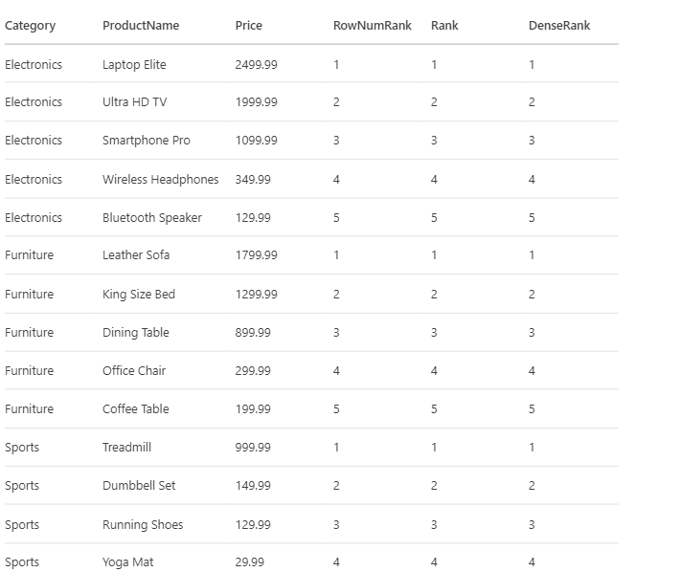

Top 3 per category

